**HOW TO INCREASE THE PURCHASE OF LOCAL FASHION BRAND ON E-COMMERCE PLATFORMS?**

**Ina Ratnasaria, Muhammad Akmal Muarifb*, Anggi Pasca Arnub, Hannieb**

*aUniversitas Singaperbangsa Karawang, Indonesia*

*bUniversitas Singaperbangsa Karawang, Indonesia*

[*ina.ratnasari@fe.unsika.ac.id*](mailto:ina.ratnasari@fe.unsika.ac.id)

[*muhammad.akmal0701@gmail.com*](mailto:muhammad.akmal0701@gmail.com)

[*anggi.pasca@fe.unsika.ac.id*](mailto:anggi.pasca@fe.unsika.ac.id)

[*hannie@staff.unsika.ac.id*](mailto:hannie@staff.unsika.ac.id)

**Abstract**

*Progress of the fashion industry is growing very rapidly in the national industry. Erigo is one of the local fashion brands that are in demand by the public. Increasing of the fashion industry is matched by the progress of the digital world. Shopee is one of the e-commerce platforms that provides a special space for local fashion brands. This research uses quantitative methods with descriptive and verifiative approaches. The population in this study was the followers of the Shopee Erigo account using the Taro Yamane formula to determine the number of samples and found the results of 400 respondents. The sampling method used in this study was purposive sampling. This study used scale range analysis techniques and Partial Least Square Regression with tools by Smart PLS 4.0 software data. The results of this study showed a partial influence of Social Media Branding by 21.4%, Shopping Lifestyle by 56.5%, Fashion Involvement by 16.4% on Purchasing Decisions. The simultaneous influence of Social Media Branding, Shopping Lifestyle, Fashion Involvement on Purchasing Decisions has a value of 75.2% which is classified into the category of strong influence and 24.8% influenced by other factors that were not examined in this study.*

**Keywords:** *Social Media Branding, Shopping Lifestyle, Fashion Involvement and Purchasing Decisions*

**Introduction**

Very rapid technological advances have impacted all aspects of life such as social, cultural, economic, artistic including information and communication technology (ICT). Information technology relates to all processes, uses or transfers of information through various media available as tools to help manage existing information. Meanwhile, referring to research (Huda, 2020) revealed that communication technology is useful as a tool that processes and transfers existing data from one place to another intended place. So it can be said that information and communication technology are very closely related to each other.

The millennial era is referred to as the peak era of the transition of the world of information technology into all-digitalization where every individual and group every day, every second does not stop using digital technology. According to (Danuri, 2019) Digital technology is present as a continuation of the inivation of information and communication technology where these activities prioritize activities controlled by computers or Artificial Intelligence which rarely uses human power as its control center. Technology this tends to provide an automated system that is pre-programmed by the programmer.

Digitalization has entered all major sectors of life, so it will indirectly change all processes and life orders in the community. For example, people who originally could only buy something by making physical contact for buying and selling activities, with this we are facilitated by relying only on intelligence from computer programs by doing these activities from home or remotely. In his opinion (Danuri, 2019), there are updates in the digitalization system such as the emergence of digital transactions, virtual face-to-face activities to the creation of digital companies which are considered all-digital activities will reduce the risk of limited space and time, so that they can carry out these activities anywhere and anytime.

The impact of digitalization has made many changes, especially in the attitude of adapting to change. An open attitude towards change must be applied so that we will always be more adaptable to the innovation of digitalization of the internet world today. As in research (Annur, 2022) that more and more people are aware of how important it is to adapt to digital innovation, this will lead to a very significant increase in the number of internet users.

In addition to the use of the internet for social media, the use of the internet is currently also growing to be used to access online buying and selling services through e-commerce. As research conducted by (Chong et al., 2022) suggests that people in Indonesia tend to be comfortable with the presence of e-commerce in carrying out shopping activities. The existence of this convenience has a major impact on the rapid development of e-commerce in Indonesia which is supported by a large population of Indonesian people who are also the majority of them are already connected to the internet.

Referring to research (Muqoddas et al., 2020) there are several large e-commerce that appeared first in Indonesia which encouraged other companies in making similar e-commerce. Tokopedia became one of the first originators in 2014 by launching a mobile application for the Android platform. Followed by the presence of Lazada in 2015 and then Shopee which made a new trend in the world of e-commerce.

Shopee is an e-commerce that is often accessed by internet users in Indonesia. Shopee has indeed become the prima donna of e-commerce in recent years because some of the offers and discounts they offer are cheaper and complete than other e-commerce in Indonesia.

New features presented by Shopee regarding support for local brands. The new feature is a collection of stores that sell local Indonesian goods from several sellers in various regions. This feature also makes it easier to find and sort all local products with unique offers offered by these sellers.

The emergence of local brands is supported by the increasing creativity of the younger generation in developing their hobbies and talents that they previously had and conditions that in recent years the digitalization era has increased. Armed with knowledge and references from international brands that already have big names before, they try to make an innovation to make a local work as one of the product identities owned by the country.

One of the highlights is the progress of the fashion industry which is very rapidly growing in the national industry. They flocked to use their creativity and ability in designing to create a new trend in the fashion world. They make this trend as a proving ground for local brands in facing competition with international brands that have dominated fashion in Indonesia before. They prove that Indonesian fashion model designs have unique characteristics so that they can be worthy of competing and captivating the hearts of the public Indonesia, especially for young people. According to (Nurmalisa, 2017) the younger generation is categorized into the age range of 16 years to 35 years which is still classified as the younger generation.

Modernization supports the formation of many new shopping places so that this greatly influences consumers in making purchasing decisions with varied shopping alternatives. In this condition, consumers will filter purchasing decisions through quality and brand image as a consideration (Supriyadi et al., 2017).

Based on research (Hidayat et al., 2012) The rapid increase in the use of social media makes business actors take advantage of this for business development. This is evidenced by previous research which said that as much as 62% of the utilization carried out in social media as the use of online business transactions.

Erigo, is the result of the innovation of local fashion brands which are currently experiencing a fairly rapid increase in recent years. Erigo is currently one of the local fashion trends that is in great demand by the public, especially by young people. This local brand, founded by Muhammad Sadad in 2011, has stolen a lot of attention in fashion among young people in Indonesia.

Based on the writing (Parapuan, 2021) in tribunnews.com, Erigo has a fashion reference as a reference for the fashion models they issue, namely Street Style. Street Style is collaborated with several designs that refer to the trend of Japanese Street Style and European Street Style as the main characteristics of the fashion innovations they make. Erigo made the style reference based on the fashion preferences of today's young people.

Erigo has a strong influence today in the potential of local brands on people's lifestyles because of the influence of Digital Marketing that it does. They do an online promotion because they want to attract engagement with their consumers. There are several ways that Erigo does to get this, namely by working with influencers or leading artists, bundling discounts on products to participating in fashion events, one of which is Paris Fashion Week and New York Fashion Week which they recently participated in by attracting their brand ambassadors.

Erigo's branding is said to be successful or not depending on the response issued by the younger generation itself as the main target. This is reinforced by the statement of fashion involvement put forward by (Sholihah et al., 2017) that someone needs involvement in the product due to interests, needs and interests about the product.

**Literature Review**

According to (Boddy, 2017) suggests that management is the art and knowledge of designing, implementing and evaluating the results of cross-functional decisions that can be implemented by an organization to achieve organizational goals. From the understanding stated by David above, it can be concluded that management has 4 main functions including planning, organizing, actuating, controlling in carrying out management science.

Meanwhile, according to (Robbins et al., 2016) argues that management science Management refers to the process of coordinating and integrating work activities so that work can be done properly. effective with and through others. Robbins also emphasized that the manager's role has a major impact on the functioning of the management function to ensure all functions run well.

The dimensions of purchase decisions stated by (Singh et al., 2018) there are 6 dimensions including, product choice, brand choice, dealer choice, purchase amount, purchase timing, payment method.

According to (Chaffey et al., 2016) suggests that Digital Marketing is the use and application of digital media-based integrated with traditional communication technology to achieve marketing goals.

According to (Jokinen, 2016), branding in social media is one way of marketing carried out by companies to take advantage of the attention and involvement of consumers around the world by increasing interaction with clients who have been determined to carry out their product dissemination activities and used again as a medium for improving brand quality.

**Research Methods**

Research method is a way used in research to collect research data. According to (Fatihudin, 2020) the research method is a technique used when sampling techniques, data collection, determining analytical tools and how to determine hypotheses scientifically. The scientific method is a way to know an object systematically. The scientific method is a combination of deductive and inductive ways of thinking. The scientific method occurs because it is supported by scientific characteristics such as rational, empirical and systematic. Rational means reasonable, meaning that it can be reached by human reason. Empirical means that it can be observed by the five human senses, so that it can be observed and known by others. Systematic means the process that is passed by thinking using certain steps logically.A paper for publication in Journal must contain a title, names and affiliations of the authors, a list of keywords, a brief abstract at the beginning, a conclusion section at the end of the main body, and a list of references that follows the conclusion section. The manuscript must be typewritten with single spacing and wide margins, on a single side of an A4 paper. The text should be in single-column format. Times New Roman typeface should be used throughout. A handwritten manuscript will not be accepted for review. Each page should be numbered beginning with the title page to facilitate review.

The method chosen in this study is a descriptive and verifiative research method. According to (Sugiyono, 2018) This descriptive research was conducted to identify independent variables or just the existence of one or more variables (independent or independent variables) without having to compare the variables themselves and look for relationships with other variables. Descriptive analysis methods can be used to study research phenomena or main questions. Meanwhile, verifiative research is identified through evidence to test the results of hypotheses from descriptive research by means of statistical calculations so that evidentiary results are obtained which are shown by the acceptance or rejection of hypotheses that have been made.

**Results**

**Validity Test**

**Table 1. Validity Test**

|  |  |  |  |  |
| --- | --- | --- | --- | --- |
| **No** | **Indicators** | **Coefisien** | **Kriteria** | **Inform** |
|  | **Social Media Branding** |  |  |  |
| 1 | Content presented | 0,853 | 0,300 | Valid |
| 2 | Message delivery style | 0,650 | 0,300 | Valid |
| 3 | Message suitability | 0,737 | 0,300 | Valid |
| 4 | Reciprocal | 0,851 | 0,300 | Valid |
| 5 | Product attribute | 0,749 | 0,300 | Valid |
| 6 | Price | 0,417 | 0,300 | Valid |
| 7 | product dimensions, | 0,829 | 0,300 | Valid |
| 8 | Sophistication | 0,764 | 0,300 | Valid |
|  | **Shopping Lifestyle** |  |  |  |
| 1 | Shopping activities in your spare time | 0,619 | 0,300 | Valid |
| 2 | Monitoring activities for product updates | 0,829 | 0,300 | Valid |
| 3 | Interest in a product based on its type | 0,614 | 0,300 | Valid |
| 4 | Interest in a brand | 0,837 | 0,300 | Valid |
| 5 | Point of view regarding the product | 0,648 | 0,300 | Valid |
| 6 | Point of view on fashion trends | 0,805 | 0,300 | Valid |
|  | **Fashion Involvement** |  |  |  |
| 1 | Have clothes with the latest trend models | 0,832 | 0,300 | Valid |
| 2 | Fashion is an important thing to support activities | 0,630 | 0,300 | Valid |
| 3 | The clothes you wear are different from those of other people | 0,638 | 0,300 | Valid |
| 4 | Characteristics of a person's clothing | 0,849 | 0,300 | Valid |
| 5 | You can tell a lot about a person through the clothes they wear | 0,529 | 0,300 | Valid |
| 6 | Make other people attractive when wearing your favorite clothes | 0,837 | 0,300 | Valid |
| 7 | Try or look first before deciding to buy | 0,319 | 0,300 | Valid |
| 8 | Know the latest fashion trends before anyone else | 0,629 | 0,300 | Valid |
|  | **Purchase Decision** |  |  |  |
| 1 | The need for a product. | 0,766 | 0,300 | Valid |
| 2 | Diversity of product variations. | 0,386 | 0,300 | Valid |
| 3 | Product quality. | 0,743 | 0,300 | Valid |
| 4 | Trust | 0,811 | 0,300 | Valid |
| 5 | Brand Popularity | 0,781 | 0,300 | Valid |
| 6 | Ease of Obtaining Products | 0,763 | 0,300 | Valid |
| 7 | Product availability | 0,331 | 0,300 | Valid |
| 8 | Purchasing decisions for inventory | 0,316 | 0,300 | Valid |
| 9 | Time intensity of purchases on weekdays | 0,730 | 0,300 | Valid |
| 10 | Time intensity of purchases on holidays | 0,778 | 0,300 | Valid |
| 11 | Time intensity of purchases during promotions. | 0,430 | 0,300 | Valid |
| 12 | Ease of making product payments | 0,773 | 0,300 | Valid |

**Source: SPSS 25.0 Version**

According to (Sugiyono, 2018) the validity test with the criterion of a correlation coefficient > 0.300 means that all data is valid. If the correlation coefficient value is <0.300, then the indicator is declared invalid. Based on all the values ​​above, all variables tested are said to be valid because all values ​​are >300.

**Reliability Test**

**Table 2. Validity Test**

|  |  |  |  |
| --- | --- | --- | --- |
| **Variabel** | ***cronbach’s alpha*** | **Criteria** | **Inform** |
| ***Social Media Branding* (X1)** | 0,905 | 0,60 | Reliable |
| ***Shopping Lifestyle* (X2)** | 0,882 | 0,60 | Reliable |
| ***Fashion Involvement* (X3)** | 0,855 | 0,60 | Reliable |
| **Purchase Decision (Y)** | 0,909 | 0,60 | Reliable |

**Source: SPSS 25.0 Version**

According to (Sugiyono, 2018), this reliability test is seen from the Cronbach's alpha value > 0.60 to declare the data reliable. Based on the picture above, it can be concluded that all the variables tested in this study are declared reliable. It can be seen that all variables have a value of > 0.60.

**Measurement Model Test (Outer Model)**

**Table 3. Test Measurement Model (Outer Model)**

|  |  |  |  |
| --- | --- | --- | --- |
| **Variables** | ***Composite Reliability*** | ***Cronbach’s Alpha*** | **Average Variance Extracted** |
| *Social Media Branding* | 0.853 | 0.756 | 0.663 |
| *Shopping Lifestyle* | 0.849 | 0.838 | 0.754 |
| *Fashion Involvement* | 0.832 | 0.823 | 0.591 |
| Keputusan Pembelian | 0.893 | 0.883 | 0.743 |

**Source: Processed Smart PLS 4.0**

According to (Juliandi, 2018) and (Irwan et al., 2015) All the values above have been fulfilled the criteria becuse the scores of Composite Reliability have passed over >0,6, and The scores of Cronbach’s Alpha have passed over α > 0,5, and also The AVE scores have passed over 0,5. So all the scores from the test above have passed the criteria and can be continued for the next tests.

**Table 4. Testing 2 Cross Loadings (Outer Model)**

| **Variabel** | **Indikator** | **X1** | **X2** | **X3** | **Y** |
| --- | --- | --- | --- | --- | --- |
| ***Social Media Branding*** | **BPR1 (X1)** | **0.868** |  |  |  |
| **BPS2 (X1)** | **0.636** |  |  |  |
| **KPSM13 (X1)** | **0.912** |  |  |  |
| ***Shopping Lifestyle*** | **SLI1 (X2)** |  | **0.848** |  |  |
| **SLO1 (X2)** |  | **0.872** |  |  |
| **SLO2 (X2)** |  | **0.885** |  |  |
| ***Fashion Involvement*** | **FI1 (X3)** |  |  | **0.840** |  |
| **FI2 (X3)** |  |  | **0.723** |  |
| **FI3 (X3)** |  |  | **0.830** |  |
| **FI5 (X3)** |  |  | **0.623** |  |
| **FI8 (X3)** |  |  | **0.806** |  |
| **Keputusan Pembelian** | **KPBC2 (Y)** |  |  |  | **0.909** |
| **KPPC3 (Y)** |  |  |  | **0.884** |
| **KPPT1 (Y)** |  |  |  | **0.748** |
| **KPPT2 (Y)** |  |  |  | **0.897** |

**Source: Processed Smart PLS 4.0**

A construct is said to have a high discriminant validity value if the correlation value between the construct indicators is higher than the correlation value of the related indicators. According to (Juliandi, 2018) the cross loadings value meets the criteria if > 0.60 so it can be concluded that discriminant validity is declared good. Based on the values ​​above, these indicators have entered the criteria with a value of > 0.6.

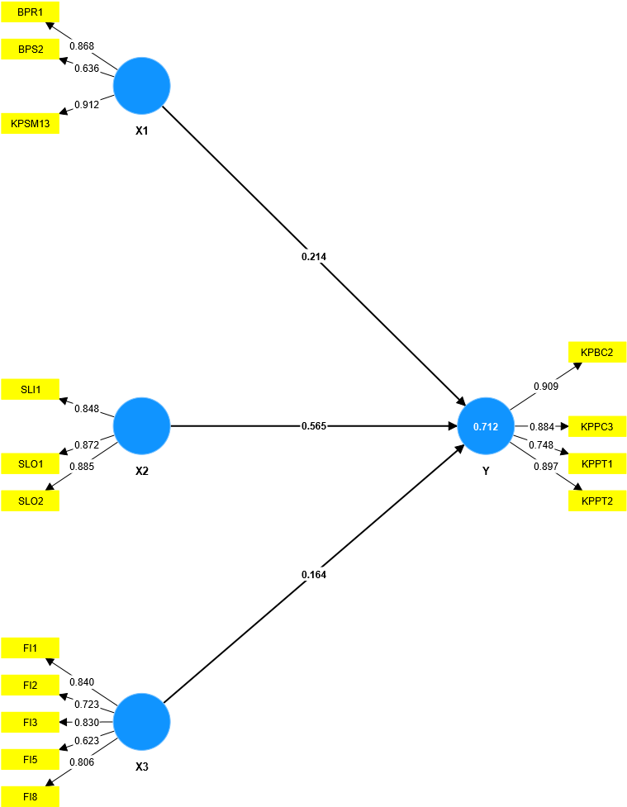

**Source: Processed Smart PLS 4.0**

**Figure 1. Second Test Path Coefficient Model**

The image above will be a reference for viewing the scale range for measuring the frequency of answers from the 400 respondents collected. The frequency of answers collected will produce a total score which is the basis for measuring the scale range displayed on the scale bar so that the results become a descriptive explanation of each indicator tested from the questionnaire results.

**Structural Model Test (Inner Model)**

**Table 5. Structural Model Analysis (Inner Model)**

|  |  |  |  |
| --- | --- | --- | --- |
| ***R-Square*** | | | |
|  | ***R-square*** | | ***R-square adjusted*** |
| **Y** | 0.752 | | 0.760 |
| ***f-Square*** | | | |
|  | | **f-square** | |
| **X1 -> Y** | | 0.066 | |
| **X2 -> Y** | | 0.520 | |
| **X3 -> Y** | | 0.054 | |
| ***Variance Inflation Factor* ( VIF )** | | | |
|  | | **VIF** | |
| **X1 -> Y** | | 2.421 | |
| **X2 -> Y** | | 2.133 | |
| **X3 -> Y** | | 1.715 | |
| **Direct Influence** | | | |
|  | *Original sample (O)* | | *P values* |
| X1 -> Y | 0.214 | | 0.000 |
| X2 -> Y | 0.565 | | 0.000 |
| X3 -> Y | 0.164 | | 0.000 |
| **Total Influence** | | | |
|  | *Original sample (O)* | | *P values* |
| X1 -> Y | 0.214 | | 0.000 |
| X2 -> Y | 0.565 | | 0.000 |
| X3 -> Y | 0.164 | | 0.000 |

**Source: Processed Smart PLS 4.0**

According to (Juliandi, 2018), the R-square assessment criteria if the R2 (adjusted) value is 0.75, the model is said to be substantial (strong), whereas in the f-square assessment criteria if the f2 value is 0.35, it is said to have a large effect. According to (Sarstedt et al., 2017) the value set for the Variance Inflation Factor (VIF) must be < 5. In Direct Influence and Total Influence, probability or significance value (P-Value): If P-Value < 0.05 it is said to be significant , If P-Value > 0.05 it is said to be not significant. Judging from the value above, the P-Value score can be said to be significant because it passes the criteria.

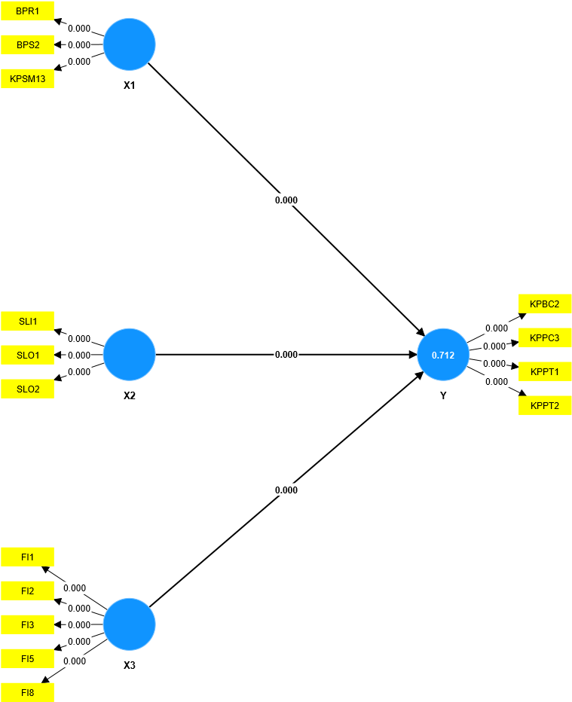

**Source: Processed Smart PLS 4.0**

**Figure 2. Second Test for Determine The Influence Between Variables**

Referring to the image above, using the bootstrapping method, it is said that all the effects that have been tested have been declared to have passed and the indicators contained in the path coefficient model above have been declared to have passed the criteria in other tests.

**Descriptive Discussion**

Descriptive discussion is measured based on 3 variables studied, namely Social Media Branding, Shopping Lifestyle, Fashion Involvement and Purchasing Decisions in the younger generation towards local fashion brand Erigo which is explained as follows.

**Social Media Branding by Erigo**

Illustrates that each respondent gets information and promotions about branding carried out by Erigo on its social media and becomes a reference for respondents to buy Erigo products. Thus, this is proof of the success of their social media promotion and this is the key to staying afloat in tough competition in gaining a presence on social media with other local brand competitors.

**Shopping Lifestyle towards Erigo products**

Interest in the product amounted to 1634 in the agreed criterion making the indicator with the greatest value that passed. This means that these results illustrate that each respondent has an attitude of fondness for shopping in everyday life to be a reference for respondents to buy Erigo products.

This is in line with the phenomenon raised in the background which states that Erigo has succeeded in utilizing twin date events and the quality of their products in convincing the younger generation in doing lifestyle shopping for Erigo products. This has also been proven through positive sales trends on the Shopee application.

**Fashion Involvement towards Erigo products**

Erigo has succeeded in following fashion trends that are in demand by the younger generation so that this is a positive trend for the Erigo brand in increasing their level of presence on social media with other local brand competitors.

**Purchase Decision on Erigo products**

Erigo has succeeded in creating new fashion trends on social media that make the younger generation interested in making purchasing decisions for Erigo products.

**Table 6. Table Hypothesis Testing**

|  |  |  |
| --- | --- | --- |
| **Hypothesis sub-struktur 1** | | |
|  | ***T statistics (|O/STDEV|)*** | ***P values*** |
| **X1 -> Y** | 4.603 | 0.000 |
| **Hypothesis sub-struktur 2** | | |
|  | ***T statistics (|O/STDEV|)*** | ***P values*** |
| **X1 -> Y** | 15.579 | 0.000 |
| **Hypothesis sub-struktur 3** | | |
|  | ***T statistics (|O/STDEV|)*** | ***P values*** |
| **X1 -> Y** | 4.655 | 0.000 |
| **R-Square** | | |
|  | **R-square** | **R-square adjusted** |
| **Y** | 0.752 | 0.760 |

**Source: Processed Smart PLS 4.0**

**Verification Discussion**

The discussion of this verification method is explained based on 3 variables studied, namely Social Media Branding, Shopping Lifestyle, Fashion Involvement and Purchasing Decisions in the younger generation towards local fashion brand Erigo which is explained as follows.

**Discussion of the Partial Influence of Social Media Branding (X1), Shopping Lifestyle (X2) and Fashion Involvement (X3) on Purchasing Decisions (Y)**

1. Social Media Branding influences Purchasing Decisions

The partial influence of social media branding on purchasing decisions is the path coefficient value of 0.214 or 21.4% and the P-value of 0.000 (<0.05). This means that Social Media Branding has a partial influence on Purchasing Decisions. This is in line with research conducted by (Novita et al., 2020), (Refiani et al., 2020), and (Praditasetyo et al., 2021) which states that social media branding has a significant partial effect on purchasing decisions.

1. *Shopping Lifestyle influences Purchasing Decisions*

The partial influence of shopping lifestyle on purchasing decisions is with a path coefficient value of 0.565 or 56.5% and a P-value of 0.000 (<0.05). Thus it is concluded that Shopping Lifestyle has a positive influence on Purchasing Decisions. This is in line with research conducted by (Mahmudah, 2020), (Fitra Dwi Prayogo et al., 2021), and (Pasaribu et al., 2022) which states that social media branding has a significant partial effect on purchasing decisions.

1. Fashion Involvement influences Purchasing Decisions

The partial influence of fashion involvement on purchasing decisions is with a path coefficient value of 0.164 or 16.4% and a P-value of 0.000 (<0.05). Thus it is concluded that fashion involvement has a positive influence on purchasing decisions. This is in line with research conducted by (Mahmudah, 2020), (Fitra Dwi Prayogo et al., 2021), and (Pasaribu et al., 2022) which states that social media branding has a significant partial effect on purchasing decisions.

**Discussion of the Simultaneous Influence of Social Media Branding (X1), Shopping Lifestyle (X2) and Fashion Involvement (X3) on Purchasing Decisions (Y)**

The simultaneous influence of Social Media Branding, Shopping Lifestyle and Fashion Involvement on Purchasing Decisions is seen from the R-square or R2 test value. Looking at the test results that the R-square value is 0.752 or 75.2%. It can be concluded that Social Media Branding, Shopping Lifestyle, and Fashion Involvement simultaneously influence Purchasing Decisions, with the results of the H0 hypothesis rejected and H3 accepted.

This is in line with research conducted by (Jokinen, 2016), (Padmasari et al., 2022), and (Izmy et al., 2016) which shows the results that Social Media Branding, Shopping Lifestyle, and Fashion Involvement have a positive and significant influence on Purchasing Decisions

**Conclusion and Suggestion**

**Conclusion**

Based on the results obtained in the test above regarding the Influence of Social Media Branding, Shopping Lifestyle and Fashion Involvement of the Young Generation on the Purchasing Decision of Local Fashion Brand Erigo on Shopee E-Commerce, the researcher got several conclusions which are explained as follows.

1. Social Media Branding done by Erigo is considered good. This can be seen from the average value obtained in the agreed position and in testing using SmartPLS that has been carried out get positive and significant results because all tests that have been passed have met the criteria that have been set.
2. Shopping Lifestyle is considered good. This can be seen from the average value obtained in the agreed position and in testing using SmartPLS that has been carried out get positive and significant results because all tests that have been passed have met the criteria that have been set.
3. Fashion Involvement owned by the younger generation has good testing value results. This can be seen from the average value obtained in the agreed position and in testing using SmartPLS that has been carried out get positive and significant results because all tests that have been passed have met the criteria that have been set. However, indicators that are said to be weak in influencing purchasing decisions such as indicators of the characteristics of one's clothes, making other people's attractiveness when wearing favorite clothes, and looking first at products before deciding to buy.
4. On the Purchase Decision variable, it has a good testing value. This is seen from all existing tests, Erigo has the largest scale range value of 1635 which is on a positive scale. This is also reinforced by overall testing that is positive and significant. However, 8 out of 12 indicators were still weak in testing.
5. The amount of partial influence of Social Media Branding is 21.4%, Shopping Lifestyle is 56.5%, Fashion Involvement is 16.4% on Purchasing Decisions. From the results above, it shows that the Shopping Lifestyle variable has a more dominant influence on Purchasing Decisions.
6. The magnitude of the simultaneous influence of Social Media Branding, Shopping Lifestyle, Fashion Involvement on Purchasing Decisions has a value of 75.2% which is classified into the category of strong influence and 24.8% influenced by other factors that were not studied in this study.

**Suggestion**

From the results of research that has been conducted on the Influence of Social Media Branding, Shopping Lifestyle and Fashion Involvement of the Young Generation on the Purchasing Decision of Local Fashion Brand Erigo on Shopee E-Commerce, researchers provide suggestions for the next researcher as follows.

1. On the social media branding variable, the author suggests to Erigo to focus more on strengthening such as communication and diversity of product variation models because in the research carried out, these indicators are still relatively weak. The recommended effort to be made is an approach with the community by creating events that attract engagement from followers to be able to find out the fashion craze that is in demand by the younger generation today.
2. In the shopping life variable, the author advises Erigo to pay more attention to indicators that are considered not yet meeting criteria such as activity and interest in a brand. The recommended effort for Erigo is to strengthen through branding through media that are popular with the younger generation and find hours when the younger generation is active on their social media. It will potentially catch their attention when they are monitoring their social media.
3. In varibael fashion involvement, the author gives advice for Erigo to pay more attention to indicators that are considered weak and do not meet criteria such as trying or seeing first before deciding to buy, feeling the center of attention when wearing, and the characteristics of one's clothes.
4. On purchasing decision variables, the author advises Erigo to focus on variables that have low values and do not meet the criteria for further improvement. The efforts made for Erigo are to maintain the quality and identity of their products by being encouraged by strong promotions so that it still maintains customer trust in the brand and has the potential to make repeat purchases in the future.

**Acknowledgement**

The research team would like to thank Lembaga Penelitian dan Pengabdian Kepada Masyarakat (LPPM) Universitas Singaperbangsa Karawang. All funds in this research are fully sourced from grant funds organised by LPPM.

**References**

1. Adiwidjaja, A. J., & Tarigan, Z. J. H. (2017). Pengaruh Brand Image Dan Brand Trust Terhadap Keputusan Pembelian Sepatu Converse. Agora - Online Graduate Humanities Journal, 5(3), 1–9. Retrieved from http://publication.petra.ac.id/index.php/manajemen-bisnis/article/view/6063

2. Danuri, M. (2019). Development and transformation of digital technology. *Infokam*, *XV*(II), 116–123.

3. Chong, D., & Ali, H. (2022). Literature Review: Competitive Strategy, Competitive Advantages, and Marketing Performance on E-Commerce Shopee Indonesia. *Dinasti International Journal of Digital Business Management*, *3*(2), 299–309. Retrieved from <https://www.dinastipub.org/DIJDBM/article/view/1198>

4. Fatmawati, N. (2020). Gaya Hidup Mahasiswa Akibat Adanya Online Shop. Jurnal Pendidikan Ilmu Sosial, 29(1), 29–38. doi: 10.17509/jpis.v29i1.23722

5. Febriani, S. F., & Purwanto, N. (2019). Pengaruh Shopping Lifestyle Dan Fashion Involvement Terhadap Impulse Buying Pada Konsumen Hijab Butik Rabbani Jombang. JMD: Jurnal Riset Manajemen & Bisnis Dewantara, 2(2), 53–62. doi: 10.26533/jmd.v2i2.372

6. Febrianti, R. A. M., Tambalean, M., & Pandhami, G. (2021). The Influence of Brand Image, Shopping Lifestyle, And Fashion Involvement to the Impulse Buying. Review of International Geographical Education Online, 11(5), 2041–2051. doi: 10.48047/rigeo.11.05.110

7. Ferbita, L. V., Setianti, Y., & Dida, S. (2020). Strategi Digital Branding Lembaga Ilmu Pengetahuan Indonesia (LIPI) melalui Media Sosial Era digital dimulai dengan semakin pesatnya jaringan internet . Kondisi menyebabkan pergeseran budaya manusia dalam berkomunikasi dan berinteraksi satu sama lain . Jurnal Ilmu Komunikasi Acta Diurna, 16(2), 113–136. Retrieved from http://jos.unsoed.ac.id/index.php/acta_diurna/article/view/2865

8. Fitra Dwi Prayogo, Christina Menuk Srihandayani, & Tony Susilo Wibowo. (2021). Pengaruh Shopping Lifestyle, Sales Promotion Dan E-Service Quality Terhadap Keputusan Pembelian Pengguna Tokopedia Di Desa Jotangan Mojokerto. Majalah Ekonomi, 26(1), 29–39. doi: 10.36456/majeko.vol26.no1.a3951

9. Juliandi, A. (2018). SEM PLS dengan Smart PLS. 16–17. doi: 10.5281/zenodo.2538001

10. Muqoddas, A., Yogananti, A. F., & Bastian, H. (2020). Usability User Interface Desain pada Aplikasi Ecommerce (Studi Komparasi Terhadap Pengalaman Pengguna Shopee, Lazada, dan Tokopedia). *ANDHARUPA: Jurnal Desain Komunikasi Visual & Multimedia*, *6*(1), 73–82. doi: 10.33633/andharupa.v6i1.3194

11. Nurmalisa, Y. (2017). Pendidikan Generasi Muda. *Media Akademi*, 1–94. Retrieved from http://repository.lppm.unila.ac.id/11009/1/APROVAL-PENDIDIKAN GENERASI MUDA.pdf

12. Supriyadi, S., Wiyani, W., & Nugraha, G. I. K. (2017). Pengaruh Kualitas Produk Dan Brand Image Terhadap Keputusan Pembelian. *Jurnal Bisnis Dan Manajemen*, *4*(1), 74–85. doi: 10.26905/jbm.v4i1.1714

13. Hidayat, A. T., Elita, M. F., & Setiaman, A. (2012). Hubungan antara atribut produk dengan minat beli konsumen. *EJurnal Mahasiswa Universitas Padjadjaran*, *1*(1), 1–14. Retrieved from <http://journals.unpad.ac.id>

14. Boddy, D. P. (2017). *Management An Introduction* (Seventh Ed). Edinburgh Gate: Pearson.

15. Robbins, S. P. (Sa. D. S. U., & Coutler, M. S. U. (2016). Management and organization. In Surface Mining (eleventh e). doi: 10.4324/9781315024790-16

16. Singh, H., Kotler, P., & Keller, K. L. (2018). Marketing Management. In Essentials of Management for Healthcare Professionals. doi: 10.4324/9781315099200-17

17. Chaffey, D., & Chadwick-Ellis, F. (2016). Strategy, Implementation and Practice. In Digital Markerting. Retrieved from www.pearson.com/uk

18. Jokinen, T. (2016). *Branding in Social Media and the Impact of Social Media on Brand Image*. *1*(April), 65.

19. Fatihudin, D. (2020). *METODE PENELITIAN UNTUK ILMU EKONOMI, MANAJEMEN DAN AKUNTANSI Dari Teori ke Praktek*. Retrieved from [zifatama@gmail.com](mailto:zifatama@gmail.com)

20. Padmasari, D., & Widyastuti, W. (2022). Influence of Fashion Involvement, Shopping Lifestyle, Sales Promotion on Impulse Buying on Users of Shopee. Jurnal Ilmu Manajemen, 10(1), 123–135. doi: 10.26740/jim.v10n1.p123-135

21. Panta, N. S. (2022). Influence of Fashion Involvement, Attitude, and Price, Toward Purchase Intention of Ethnic Weaving. International Journal of Current Science Research and Review, 05(02), 424–434. doi: 10.47191/ijcsrr/v5-i2-16

22. Pasaribu, V. T., Yamani, A. Z., & Romadlon, F. (2022). Pengaruh Kualitas Produk, Shopping Lifestyle, dan Visual Merchandising Terhadap Keputusan Pembelian (Studi Kasus Produk Eiger). J-MAS (Jurnal Manajemen Dan Sains), 7(2), 1133. doi: 10.33087/jmas.v7i2.709

23. Praditasetyo, D., & Saputri, M. E. (2021). Pengaruh Social Media Marketing Melalui Aplikasi Tiktok Terhadap Keputusan Pembelian Online Pada Shopee Indonesia. EProceedings of Management, 8(5), 6507–6517.

24. Pramestya, N. L. P. U. M., & Widagda, I. J. A. (2020). the Role of Positive Emotion Mediates Fashion. American Journal of Humanities and Social Sciences Research (AJHSSR), 4(9), 1–8. Retrieved from https://www.ajhssr.com/wp-content/uploads/2020/08/A20490108.pdf

25. Prasetya, F. R. (Universitas N. J., Suhud, U. (Universitas N. J., & Aditya, S. (Universitas S. K. (2023). Menguji Faktor – Faktor Determinasi Belanja Produk Fashion Apparel Saat Live Streaming Di Media Sosial. 1(5), 1349–1364.

26. Sarstedt, M., Ringle, C. M., & Hair, J. F. (2017). Handbook of Market Research. In Handbook of Market Research (Issue September). doi: 10.1007/978-3-319-05542-8

27. Sugiyono. (2018). *Metode Penelitian Kuantitatif*. Bandung: Alfabeta.

28. Štreimikienė, D., Mikalauskienė, A., Sturienė, U., & Kyriakopoulos, G. L. (2021). The impact of social media on sales promotion in entertainment companies. E a M: Ekonomie a Management, 24(2), 189–206. doi: 10.15240/tul/001/2021-2-012