EFFECT SUPPLY ASPECT TOURISM TO INTEREST OF TRAVELLING TO MOUSE ISLAND
BENGKULU PROVINCE

Herlinª, Ida Ayu Made Er. Meytha Gayatriª
Dehasen University Bengkulu, Indonesia
Herlin_olin81@yahoo.com

ABSTRACT

The study aim to examine the effect suplly aspect tourism to interest of travelling to mouse island Bengkulu Province. The results of this research prove that supply aspect tourism consisting of anttraction, accesable, amenities and ancyllary. Where is attraction take effect to interest of travelling to mouse island of Bengkulu Province. Accesable take effect to interest of travelling to mouse island of Bengkulu Province. Amenities no effect to interest of tourism to mouse island of Bengkulu Province. Ancillary no effect to interest of travelling to mouse island of, Bengkulu Province.

Keyword : Supply aspect tourism, attraction, accessibility, amenities, ancillary, interest of travelling, mouse island Bengkulu Province

Introduction
Indonesia is one of the countries that has become a tourist destination, so it is not surprising that many foreign tourists who come on vacation to Indonesia, which has an impact on increasing the regional income sector in the field of tourism. The contribution of the tourism sector to the revenues of the regional government, both directly and indirectly, makes the economy around tourism places better, such as the absorption of labor and the creation of tourism-related businesses such as accommodation, restaurants, clubs, taxis and souvenir craft businesses. (Main, 2016).

Regional Original Income from the tourism sector will increase if many visitors come to travel. So, to attract interest in traveling to a tourist attraction, tourism supplies are needed that offer interesting things from managed tourism objects such as various attractions and facilities. Attractions that offer attraction, complete facilities and satisfying services will be visited by many tourists. According to Utama (2016) as for the factors that can affect tourism offerings (tourism supply) are tourist attractions, hotels or accommodations, immigration services, restaurants, shopping centers and transportation. With a growing number of attractions When visiting tourist destinations, tourists expect a positive experience so that supply (Supply) is one of the determining factors in giving a positive impression by Payangan (2017).

The mouse island of Bengkulu Province is one of the attractions included in the potential category developed by the Bengkulu Province Tourism Service visiting visit the wonderful Bengkulu (Source: Bengkulu Provincial Tourism Office). Results of research Herlin et al (2018), is proven that the mouse island tourism development strategy that can be applied is the development in the transportation sector and supporting facilities in the mouse island tourist area. The application of appropriate strategies in the development of rat island tourism and the attractiveness of mouse islands that are not owned by other tourist attractions in Bengkulu province make many visitors who are interested in traveling to the mouse island, thus increasing the Bengkulu Province's Original Revenue.

Literatur Review
Tourism
Meyers (2009) defines tourism as a travel activity carried out temporarily from the original place of residence to the destination area with the excuse not to settle or earn a living but only to have fun, fulfill curiosity, spend leisure time or holiday time and destination - other purposes. According to Republic of Indonesia's Law No. 9 of 1990 concerning tourism (2016), tourism business consists of (1) tourism services, (2) business of tourist objects and attractions, (3) tourism facilities business

Suplay Effect tourism
According to Republic of Indonesia's Law No. 9 of 1990 concerning tourism (2016), tourism business consists of (1) tourism services, (2) business of tourist objects and attractions, (3) tourism facilities business. Utama (2016) there are 4 (four) indicators that must be considered in tourism offerings:
- Attraction, Regional tourist destinations to attract tourists must have an attraction, both the attraction of nature and society and culture.
- Accessible, Transportation is intended so that domestic and foreign tourists can easily reach the destination to tourist attractions.
- Amenities, facilities are indeed one of the requirements for tourist destinations in order to be able to stay longer in tourist destinations.
- Ancillary, The existence of tourist tourism agencies will increasingly visit and search for tourist destinations if the area tourists can feel security (protection of tourism) and protected.

Interest of Tourism
The theory of interest in visiting or traveling in research conducted by Albarq (2014) and Jalilvand and Samiei (2012) which equates that tourists visiting interests are the same as the interests of consumer purchases. Kotler and Keller (200) in Fitri aprial et al (2015) there are two external factors that influence someone's buying interest. First, the attitude of others, in this case the attitude of others who influence buying interest depends on two things. Second, situations that are not inspired, are situations that suddenly appear and can indirectly change consumers' buying interest

Hypothesis
- Suspected that there is an attraction influence on the interest in traveling to Mouse Island of Bengkulu Province.
- Suspected that there is an accessible influence on the interest in traveling to Mouse Island of Bengkulu Province.
- Suspected there are amenities that influence the interest in traveling to Mouse Island of Bengkulu Province.
- Suspected there is an ancillary influence on the interest in traveling to Mouse Island of Bengkulu Province.

Research Methods
The place of this research carried out area ​​tourism objects in the city of Bengkulu, namely the beaches of Tapri Padri, Pantai Pantai and Long Beach which were visited by tourists both from the city of Bengkulu and from outside the city of Bengkulu.

Sampling Methods
The sampling method in this study uses sampling techniques, namely accidental sampling. The population in this study is large and in number be known, so the determination of the sample formula Rao Purba (1996) with the results of the 240 people and method of data collection using a questionnaire.

Analysis Method
Regression Equation is :
Interest of Travelling = a + b₁ Attraction + b₂ Accesable + b₃ Amenities + b₄ Ancillary+ e
Classic Assumption Analysis
- Normality test
Normality analysis of this data will test the independent variable data (X) and dependent variable data (Y) in the regression equation that is produced, normally distributed or not normally distributed. Data are said to be Normal, if the Kolmogorov-Smirnov statistic value (K-S) if the Significant value> α = 0.05 (Ghozali, 2013).
- Multicolonyearity Tes
Multicollinearity test was conducted to test whether the regression model was found to have a correlation between variables. A good regression model should not have a correlation between independent variables. If the tolerance value and Variance Inflation Factor (VIF) ≤ 0.10 or equal to the value of ≥ 10, then there is no multicollinearity in the regression model seen from the value of tolerance (Ghozali, 2013).
- Autocorrelation Test
Good regression equation is not having autocorrelation. to determine whether there is a problem with autocorrelation with the Durbin-Watson (DW) test. With the following conditiion is DW<-2, -2<DW<+2 or DW > 2 (Ghozali, 2013).
- Heteroscedasticity Test
Heteroscedasticity test is done to test the equal or not variance of the residual observations that one with the other observations. Heteroscedasticity test uses the Test Servers test. With a 5% confidence level. Model Feasibility Test (Ghozali, 2013).
- Test F Statistics (level of significant 5%)
- Statistical test t (level of signifiacant 5%)
- Determinant test
The determinant coefficient (R2) states how well the sample regression line matches the data

Result
Mouse Island is a small island located on the west side of the city of Bengkulu, located 10 KM from the center of Bengkulu City, which is directly connected to the Indian Ocean, geographically located at the coordinates of 3050'17,55 "LS and 102010'50,59" BT which has an area of ​​2 ha at first, and now the area of ​​rat islands is only 0.6 ha which is supported by 200 ha of coral reefs. To go to the rat island can be reached through the fishing village of Teluk Sepang, Zakat Beach and the port of Bengkulu, Bengkulu, which can be reached in approximately 1.5 hours depending on the weather conditions at that time. Mouse Island located in Teluk Segara, Benteng Marlborough, Bengkulu City.

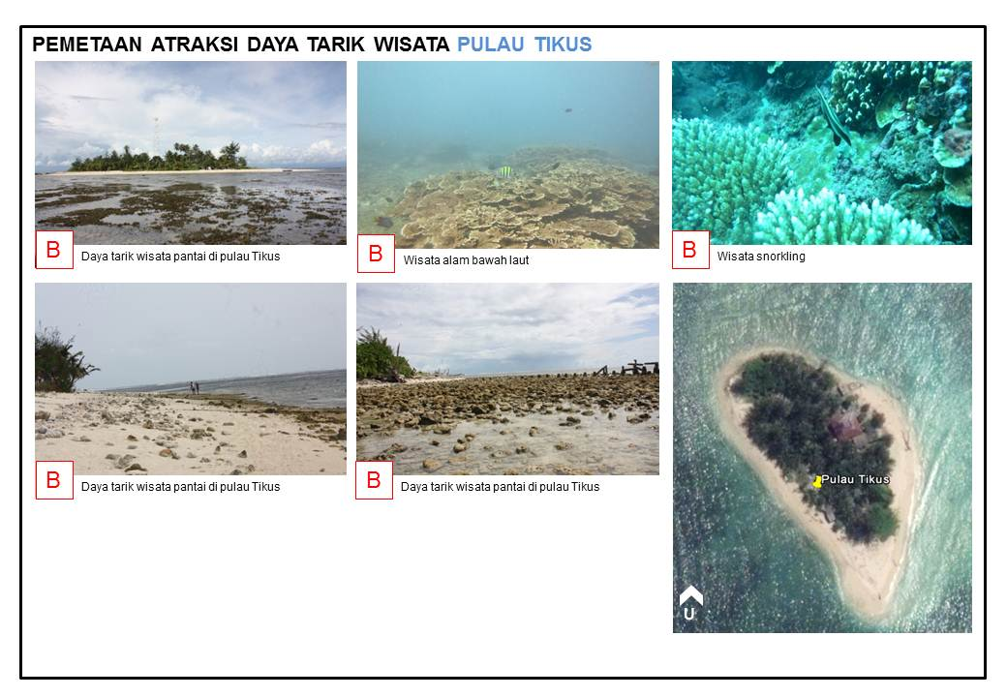

Sourch : Dinas Pariwisata Provinsi Bengkulu

Test Reability
To measure reliability by using the Cronbach Aplha statistical test with a value of 0.60. A construct or variable is said to be reliable if the value of Cronbach Aplha is greater than 0.60 (Nunnally, 1967 in Ghozali, 2005. The results of reliability testing on variables Attraction (X1) Cronbach’s Alpha value is 0,847 (reliabel), Accessable (X2) Cronbach’s Alpha value is 0,804 (reliable), Amenities (X3) Cronbach’s Alpha value is 0,635, Ancillary (X4) Cronbach’s Alpha value is 0,612 (reliable) and Travel Interests (Y) Cronbach’s Alpha value is 0,736, the value of Cronbach's Alpha is above 0, 60 (> 0, 60) which means all variables are declared reliable.

Classic assumption test
This classic assumption test is used to provide an initial test of an instrument used in data collection, which will be processed further, so that the requirements to obtain data that cannot be fulfilled, Best Linier Unbiased Estimator or BLUE is fulfilled by Wibowo (2012) . In this study the classical assumption test uses normality test, multicollinearity test, autocorcoral test and heteroscedacity test conducted using Statistical Produst and Service Solutions (SPSS) program.

Normality Test
Based on the result shows that the number of respondents (n) in this study is 240 and the Kolmogorov-Smirnov value is 1.170, where this value is greater than the 0.05 significance value, meaning that the data in this study were normally distributed.

Tabel 1. Normality Test
One-Sample Kolmogorov-Smirnov Test
Kolmogorov-Smirnov Z | 1.170

Table 2. Classic assumption test
Variabel | Multicollinearity |  | Autocorrelation | Heteroscedasticity
Variabel | Tolerance | VIP | Autocorrelation | Heteroscedasticity
Attraction | 0,929 | 1,076 | 0,266  (DW>DU : 0,266>1,822)  Free autocorrelation | 1,000
Attraction | Free multicollinearity |  | 0,266  (DW>DU : 0,266>1,822)  Free autocorrelation | Free heteroscedasticity (<0,05)
Accesable | 0,806 | 1,241 | 0,266  (DW>DU : 0,266>1,822)  Free autocorrelation | 1,000
Accesable | Free multicollinearity |  | 0,266  (DW>DU : 0,266>1,822)  Free autocorrelation | Free heteroscedasticity (<0,05)
Amenities | 0,716 | 1,397 | 0,266  (DW>DU : 0,266>1,822)  Free autocorrelation | 1,000
Amenities | Free multicollinearity |  | 0,266  (DW>DU : 0,266>1,822)  Free autocorrelation | Free heteroscedasticity (<0,05)
Ancillary | 0,771 | 1,298 | 0,266  (DW>DU : 0,266>1,822)  Free autocorrelation | 1,000
Ancillary | Free multicollinearity |  |  | Free heteroscedasticity (<0,05)

Multicollinearity test
Based on the multicollinearitas test result shows the variables used in this study are Attrasction, Accessable, Amenities and Ancillary obtaining Tolerance> 0.1 and Variant Inflation Factor (VIF) <10, so it can be concluded that the regression model used is free from multicollinearity or there is no multicollinearity between independent variable. Where is the value tolerance variabel attraction is 0,929 (multicollinearity free), accesabe is 0,806 (multicollinearity free), amenities is 0,716 (multicollinearity free) and ancillary is 0,771 (multicollinearity free).

Autocorrelation Test
Autocorrelation test result Durbin-Watson value of 0.266, greater than DU value, which means that the regression model used there is no autocorrelation between independent variables.

Heteroscedasticity Test
Heteroscedasticity Test Result shows that the probability or significance level of each variable is 1,000 so it can be concluded that the regression model used does not experience heteroscedasticity.

Regression Equation
The classic assumption test results, showing the data in this study meet the requirements to proceed to regression mode to do further hypothesis testing, with the regression model in this study.
Interest in travelling = 118,501 - 4,201X₁ – 0,647X₂ + 3,075X₃ + 8,453X₄ + e

Hypothesis Test
Table 3. Hypothesis Test Result (t-test)
Variable Independen | Variable Dependen | Coefisien Value | t_{count} | Sig | Information
Atttraction | Interest in travelling | 118,501 | 3,162 | 0,002 | Hypothesis accepted
Accesable | Interest in travelling | -4,201 | -2,958 | 0,003 | Hypothesis accepted
Amenities | Interest in travelling | -0,647 | -0,482 | 0,630 | Hypothesis rejected
Ancillary | Interest in travelling | 3,075 | 1,533 | 0,127 | Hypothesis rejected
R² = 0,417 Adj R² = 0,160 F= 12,385 Sig= 0,00
Source: Primary data is processed, 2019

Table 1 above, the coefficient of determination (Adjusted R2) is 0.160 or 16%, which means that attraction, accessable and ancillary are able to explain their influence on interest in travel, while the rest 84% influenced by other factors outside the model. Value of F-count is 12.385 with a significant value of 0.000 which means it is smaller than 0.05%.

Testing attraction of the interest in traveling to Mouse Island of Bengkulu Province obtained attraction regression coefficient on the interest of traveling by 118,501 with a significance level of 0.002 (<0.05), this proves that attraction (attraction) affects the interest in traveling to Mouse Island of Bengkulu Province, so the First Hypothesis (H1) is accepted.

Tests of accessibility towards the interest in traveling to Tikus Island, Bengkulu Province, obtained the regression coefficient value is negative at -4.201 with a significance level of 0.003 (<0.05). Regression coefficient values ​​that show negative results, thus proving that accessibility influences the interest in traveling to Mouse Island of Bengkulu Province, so the second hypothesis (H2) is accepted.

Testing of amenities for the interest in traveling to Tikus Island, Bengkulu Province, the value of the regression amenities coefficient was negative at -0.482 with a significance level of 0.630 (> 0.05). Regression coefficient values ​​with negative results, and significantly prove that amenities do not affect the interest in traveling to the Mouse Island of Bengkulu Province, so the third hypothesis (H3) is rejected.

The ancillary test on the interest in traveling to the Mouse Island of Bengkulu Province obtained ancillary regression coefficient on the interest of traveling by 1.533 with a significance level of 0.127 (> 0.05), this proves that the ancillary does not affect the interest in traveling to Mouse Island of Bengkulu Province, so the fourth Hypothesis (H4) is rejected.

Conclusion and Suggestion

Conclusion
Attraction take effect the interest in traveling to Mouse Island Bengkulu Province. Accessible take effect the interest in traveling to Mouse Island Bengkulu Province. Amenities no effect the interest in traveling to the Mouse Island Bengkulu Province. Ancillary no effect the interest in traveling to Mouse Island Bengkulu Province.

Suggestion
- Better public facilities for tourists visiting the mouse island Bengkulu Province
- There was a government-organized event on the mouse island Bengkulu Province
Reference
- Albarq, Abbas N. (2014). Measuring the Impacts of Online Word of Mouth on Tourists’ Attitude and Intentions to Visit Jordan: An Empirical Study. International Business Research; Vol. 7, No.1.
- Dilla Pratiyudha Sayangbatti1 , M. Baiquni. Motivasi dan Persepsi Wisatawan tentang Daya Tarik Destinasi terhadap Minat Kunjungan Kembali di Kota Wisata Batu Jurnal Nasional Pariwisata Volume 5, Nomor 2, Agustus 2013 (126 - 136) ISSN: 1411-9862
- Fitri, aprilia dkk (2015). Pengaruh word of muoth terhadap Minat Berkunjung Serta dampaknya Pada Keputusan Berkunjung (Survey pada pengunjung tempat wisata “Jawa Timur Park 2” Kota Batu, Jurnal Administrasu Bisnis (JAB) Vol 24 No. 1 Juli 2015, 1-6.
- Ghozali, Imam (2013). Aplikasi Analisis Multivariate Dengan Program”. Semarang. UNDIP.
- Jalilvand, Mohamad Reza and Neda Samiei. 2012. The Effect of Word of Mouth on Inbound Tourists’ Decision for Traveling to Islamic Destinations (The Case of Isfahan as a Tourist Destination in Iran). Journal of Islamic Marketing, Vol. 3 No. 1
- Kotler, Philip Dan Kevin Lane Keller. 2009. Manajemen Pemasaran. Edisi 13 Jilid satu. Jakarta. Erlangga.
- Rao Purba. (1996).Measuring consumer perception through factor analysis. The asianmanager. February-march, pp 28-23
- Sugiyono. (2011). Metode Penelitian Kuantitatif, Kualitatif dan R&D. Bandung: Afabeta.
- Utama, Rai (2016). Pemasaran Pariwisata. Yogyakarta.Andi
- Wibowo, Edy. (2012). Aplikasi Praktis SPSS Dalam Penelitian. Yogyakarta.Gava Media
- Undang-undang nomor 10 tahun 2009 tentang wisata
- https://pariwisata.bengkuluprov.go.id/

